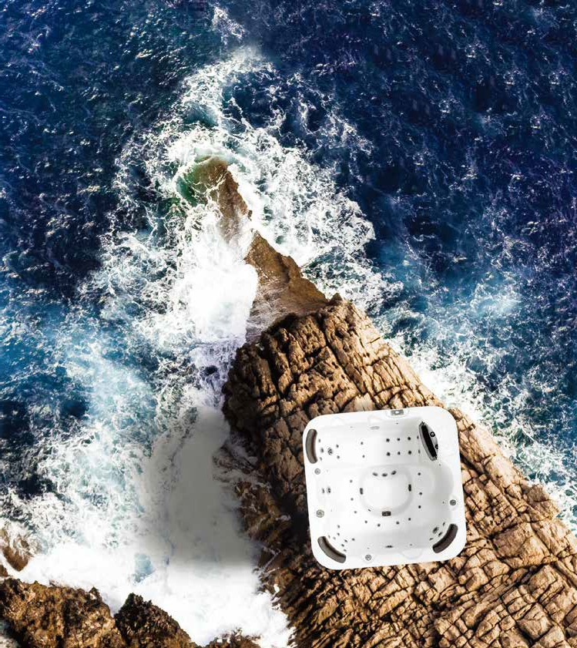

**OWNER’S**

**MANUAL**

PLEASE READ AND FOLLOW ALL INSTRUCTIONS

[www.bellagioluxury.com](http://www.bellagioluxury.com/)

manual version:20220301

# TABLE OF CONTENTS

**TABLE OF CONTENTS**

### Important Safety Instructions and Warnings 1

### Preparing for Your New Portable Spa 3

**Water Clarity** 21

**Appendix** 22

Pre-Delivery Checklist 3 Planning the Best Location 3 Clearance for Service Access 4 Opening the Front Door Panel for Electrical Hookup 5 Filling and Powering Up Your Portable Spa 7 Priming the Pump 10

Basic Troubleshooting 22 Limited Warranty 26

### Operating Your Spa 11

Spa Control Panel 11 Jets 12

LED Lighting 12 Diverter Knobs 13 Air Valve 13

Waterfalls 13

### Cleaning and Maintenance 14

Removing and Reseating the Pillows 14 Jet Removal and Replacement 14 Draining Your Portable Spa 15 Cleaning and Replacing the Filter 16 Spa Cover and Locking System Installation 17 Vacation Care 19 Cleaning Your Spa 19

#### Sound System 20

Using the Bluetooth Sound System 20

Danger! Proceed with extreme caution to prevent the risk of severe injury and/or death.

Warning! Proceed with care to prevent avoidable accidents and potential risks.

NOTE

Because different control systems have different features and options, this booklet is not intended to give specific details of the control system that is in your spa. For specific instructions on how to operate and program your spa and it's control system, please refer to the applicable control operation manual that was included with your spa.

(C) 2022, Bellagio Spas. All rights reserved

**READ AND FOLLOW ALL INSTRUCTIONS.**

**HYPERTHERMIA DANGER:**

Prolonged exposure to hot air or water can in 4˚C above 37˚C). While hyperthermia has many health benefits, it is important not to allow your body’s core temperature to rise above 103˚F (39.5˚C).

Symptoms of excessive hyperthermia include dizziness, lethargy, drowsiness and fainting. The effects of excessive hyperthermia may include:

* Failure to perceive heat
* Failure to recognize the need to exit spa or hot tub
* Unawareness of impending hazard
* Fetal damage in pregnant women
* Physical inability to exit the spa
* Unconsciousness

**DANGER -- Risk of accidental drowning:**

Do not allow children to be in or around a spa unless a responsible adult supervises them. Keep the spa cover on and locked when not in use. See instructions enclosed with your cover for locking procedures.

### DANGER -- Risk of injury:

The suction fittings in this spa are sized to match the specific water flow created by the pump. Should the need arise to replace the suction fittings, or the pump, be sure the flow rates are compatible.

Never operate the spa if the suction fitting or filter baskets are broken or missing. Never replace a suction fitting with one that is rated less than the flow rate marked on the original suction fitting.

**WARNING:** The use of alcohol, drugs, or medication can greatly increase the risk of fatal hyperthermia.

**DANGER -- Risk of electric shock:**

Install the spa at least 5 feet (1.5 meters) from all metal surfaces. As an alternative, a spa may be installed within 5 feet of metal surfaces if each metal surface is permanently bonded by a minimum #8 AWG solid copper conductor to the outside of the spa’s control box.

Do not permit any external electrical appliances, such as lights, telephones, radios, televisions, and etc., within five feet (1.5 meters) of the spa. Never attempt to operate any electrical device from inside the spa.

Replace a damaged power cord immediately. Do not bury the power cord.

Connect to a grounded, grounding-type receptacle only.

**WARNING -- To reduce the risk of injury:**

The spa water should never exceed 104˚F (40˚C). Water temperatures between 100˚F (38˚C) and 104˚F (40˚C) are considered safe for a healthy adult. Lower water temperatures are recommended for young children and when spa use exceeds 10 minutes.

High water temperatures have a high potential for causing fetal damage during pregnancy. Women who are pregnant, or who think they are pregnant, should always check with their physician prior to spa usage.

The use of alcohol, drugs or medication before or during spa use may lead to unconsciousness, with the possi- bility of drowning.

Persons suffering from obesity, a medical history of heart disease, low or high blood pressure, circulatory system problems or diabetes should consult a physician before using the spa.

Persons using medications should consult a physician before using the spa since some medications may induce drowsiness while others may affect heart rate, blood pressure and circulation.

**WARNING:** People with infectious diseases should not use a spa or hot tub.

**WARNING:** To avoid injury, exercise care when entering or exiting the spa or hot tub.

**WARNING:** Do not use drugs or alcohol before or during the use of a spa or hot tub to avoid unconsciousness and possible drowning.

**WARNING:** Do not use a spa or hot tub immediately following strenuous exercise. **WARNING:** Prolonged immersion in a spa or hot tub may be injurious to your health. **CAUTION:** Maintain water chemistry in accordance with manufacturer’s instructions.

* Please read the instructions carefully and use according to the instructions. Children should use this product under the close supervision of adults.

## **Pre-Delivery Checklist**

Most cities and counties require permits for exterior construction and electrical circuits. In addition, some communities have codes requiring residential barriers such as fencing and/or self-closing gates on prop- erty to prevent unsupervised access to the property by children. Your dealer can provide information on which permits may be required and how to obtain them prior to the delivery of your spa.

|  |
| --- |
| **Before Delivery** |
| Plan your delivery route  Choose a suitable location for the spa Lay a 5 - 8 cm concrete slab  Install dedicated electrical supply |
| **After Delivery** |
| Place spa on slab  Connect electrical components |

### Consider Your Privacy

In a cold-weather climate, bare trees won’t provide much privacy. Think of your spa’s surroundings during all seasons to determine your best privacy options. Consider the view of your neighbors as well when you plan the location of your spa.

**Provide a View with Your Spa**

Think about the direction you will be facing when sitting in your spa. Do you have a special landscaped area in your yard that you find enjoyable? Perhaps there is an area that catches a soothing breeze during the day or a lovely sunset in the evening.

* Check spa and register serial number.

### Keep Your Spa Clean

In planning your spa’s location, consider a location where the path to and from the house can be kept clean and free of debris.Prevent dirt and contaminants from being tracked into your spa by placing a foot mat at the spa’s entrance where the bathers can clean their feet before entering your spa.

12"/30cm minimum

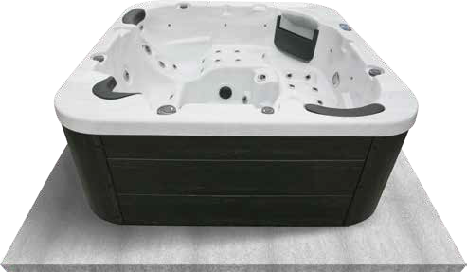

distance from edge

## **Clearance for Service Access**

While you are planning where to locate your spa, you need to determine how much access you will need for service.

All spa models require a minimum of three feet / one meter access to all sides of the spa for potential service. For this reason, the spa should never be placed in a manner where any side is permanently blocked. Examples include placing the spa against a building, structural posts or columns, or a fence.

Spa models require access to all sides in case they need service or repair. See the figure below.

If you are planning to enclose or surround your spa with a deck, make sure there is easy access for service or repair.

### Spas require clearance on all sides of the spa.

## **Planning the Best Location**

**Safety First**

Do not place your spa within 10 feet (3 m) of overhead power lines.

≈ 3 feet /

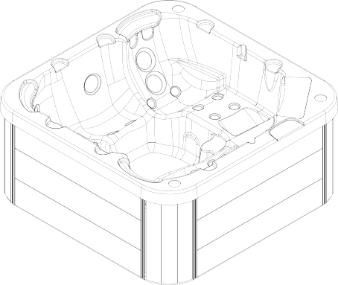

1 meter

≈ 3 feet /

1 meter

### Consider How You Will Use Your Spa

How you intend to use your spa will help you determine where you should position it. For example, will you use your spa for recreational or therapeutic purposes? If your spa is mainly used for family recreation, be sure to leave plenty of room around it for activity. If you will use it for relaxation and therapy, you will probably want to create a specific mood around it.

**Plan for Your Environment**

If you live in a region where it snows in the winter or rains frequently, place the spa near a house entry. By doing this, you will have a place to change clothes and not be uncomfortable.

≈ 3 feet /

1 meter

≈ 3 feet /

1 meter

## **Opening the Front Door Panel for Electrical Hookup**

### 2. The second way to remove and install the skirt.

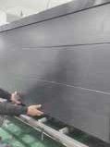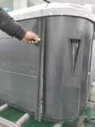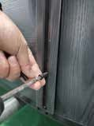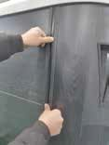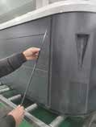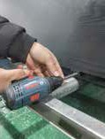

1

2

3

4

5

6

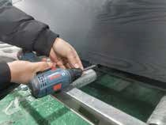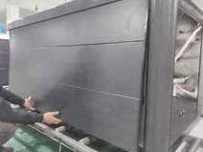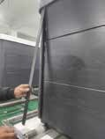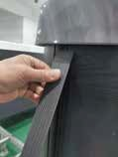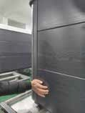

1

2

3

4

5

INSTALL

REMOVE

INSTALL

The following electrical connections must be performed by a licensed electrical contractor. Unscrew and remove the two corner panels on each side of the spa’s front door.

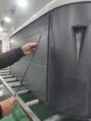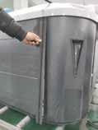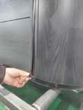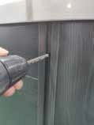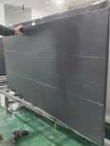

1

2

3

4

5

6

**1. The first way to remove and install the skirt.**

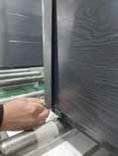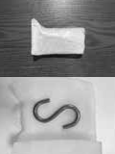

1

2

3

4

5

REMOVE

### The third way to remove and install the skirt. 2. Remove the cartridge from filter canister.

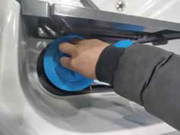

##### If you have a skimmer like this:

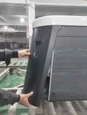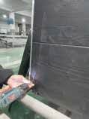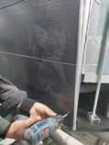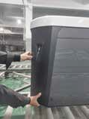

1

2

3

4

Grip the filter by the handle and unscrew it from the canister. Never try to pull the filter cartridge while the spa is running in low or high speed (i.e., any speed).

REMOVE

##### If you have a skimmer like this:

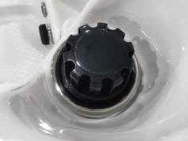

Remove the black skimmer cap and barrel, grip the filter by the handle and unscrew it from the canister.

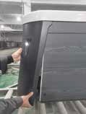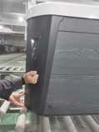

1

2

3

4

**Teleweir Mega filter skimmer**

INSTALL

* + 75 square feet filtration
  + Smooth cap

Pictured to the right is the inside of the spa behind the front door. The electrician now has access to connect the spa for power. While the front door is off, refer to page 7 for instructions on ensuring the plumbing fittings are secure (but do not be tempted to over-torque or over-tighten these fittings).

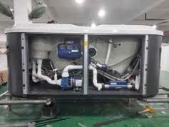

## **Filling and Powering Up Your Portable Spa**

### Inspect the spa equipment.

Inspect all plumbing connections in the equipment area of your spa.

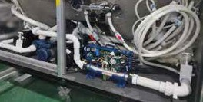

**UP**

**UP**

**TIGHTEN**

* + Make sure unions in the equipment pack are tight. (Be careful not to over-tighten the plumbing fittings.)

Never run the spa with the gate valvesclosed or without water circulating for long periods of time.

##### If you have a skimmer like this:

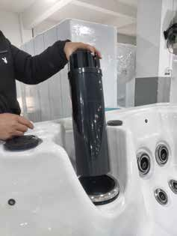

Rotate and remove the black locking ring. Remove the black skimmer cap and barrel, grip the filter by the handle and unscrew it from the canister.

Replace and lock the locking ring and slide the skimmer cap and barrel back in the canister.

**Note:** The skimmer cap and barrel were locked in place at the factory to prevent damage during shipment. It must be unlocked and replaced in the filter canister so that it can float when the spa is filled. If you do not remove the cap and barrel, your spa’s filtration system will not perform as it was designed to.

##### Teleweir filter skimmer

* 50 square feet filtration
* Spoked cap

After you remove the filter, remove the plastic wrapper and soak it in water for 30 minutes before you replace it. A dry filter can allow air into the filtration system which can cause the pump to fail to prime.

### Fill the spa.

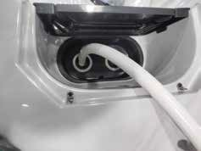

Place a garden hose in the filter canister and fill your spa.

**Always fill the spa through the filter canister.** Failure to do so may cause air to be trapped in the filtration system and prevent the pumps from operating properly.

Fill the spa until water level is about six inches from the top.

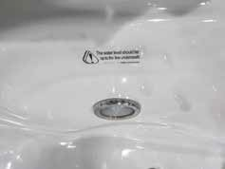

If the water level is too low or too high, your spa will not operate properly.

##### Never fill your spa with soft water.

**Soft water** makes it impossible to maintain the proper water chemistry and may cause the water to foam, which will ultimately harm the finish of the spa and void your warranty. You may fill your spa with **well water- provided the following conditions are met:** 1) Purchase and use a pre-filter to run the well water through

on the fillup. The pre-filter will be placed before the spa filter in the fill-up flow of water. 2) Have a Total

Dissolved Solids (TDS) and metals test performed by a qualified person after the fill-up process but before any spa use.

### Turn on power to the spa.

When the spa is filled to the correct level, turn on the power at the GFCI breaker.

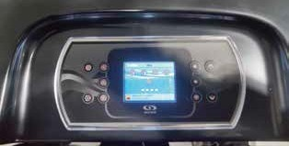

### Install the filter into the filter canister.

Make sure the filter has soaked at least 30 minutes before you install it. Insert the filter all the way and screw it in. Do not over-torque the cartridge during installation, just hand tighten gently.

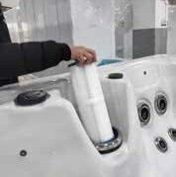

### Adjust water chemistry.

Test and adjust the water chemistry. See the section on page 21 for instructions on keeping your water clear.

### Let the spa heat up.

When the spa has finished priming, the heater will activate. Put the cover on and let the spa heat to the set temperature.

**Priming the Pump**

New spa owners often have difficulty the first time they start their spa and the pump fails to prime. This can be frustrating, but these simple instructions can help you.

Sometimes air can become trapped in the pump while filling the spa. You will know this has happened when after you have filled and started the spa, the pump does not seem to function. You will hear the pump operating, but no water will be moving.

#### The pump will not work properly while air is trapped in it.

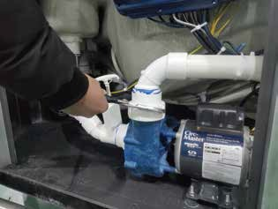

Continuing to operate the pump in this way will cause damage.

Whenever you fill your spa, fill it through the filter canister and make sure all jets are open.

## **Spa Control Panel**



|  |  |  |  |
| --- | --- | --- | --- |
|  | | | |
| **Brand** | **The name of the panel** | **Picture** | **QR code** |
| BALBOA | TP400 |  |  |
| TP600 |  |
| TP800 |  |  |
| Spa Touch |  |  |
| GECKO | IN.K300-10P |  |  |
| IN.K300-20P |  |
| IN.K506 |  |  |
| IN.K806 |  |  |
| IN.K1000 |  |  |
| JOYONWAY | PB554 |  |  |
|  |  | * Please sc | n the QR code for information. |
|  | | |
|  | | | |



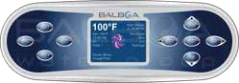 

 



 

 

 

 

a



## **Jets**

Almost all of the jets in your spa are adjustable. Rotating the face of an adjustable jet to the left will decrease the amount of water flow through the jet. Rotating the face of an adjustable jet to the right will increase the amount of water flow through the jet. (See example shown here.)

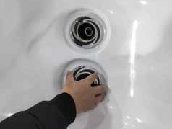

**SMALL**

**BIG**

Neck jets adjust in the opposite directions .

## **LED Lighting**

Press the LIGHT button on the topside control panel to turn the spa light on. If your spa has perimeter LED lights, they will also light up at the same time as the spa light.

The LEDs operate in three modes:

* 1. **Cycle:** When you continually press the LIGHT button, the LEDs will cycle through the three main LED colors (Red, Green, and Blue) or combinations of the three that produce the following colors: light green, purple, light blue, yellow, etc.

Each time you press the button, you immediately advance to the next color in sequence or eventually a different light pattern.

* 1. **Flashing:** When you are cycling through all the colors, the next time you push the LIGHT button, the LED lights may start flashing. This is another normal operational pattern option.
  2. **Fading cycle:** The next phase of operation when you push the LIGHT button is a slow and/or fast fade random transition from one color to the next.

Spas with exterior LED lighting generally work in the same mode as described above. The variations in color and patterns provide you with multiple options to suit almost any lighting preference.

Press the Light key to turn light on.Press the Light key a second time to turn light off.

## **Diverter Knobs**

**Removing and Reseating the Pillows**

Diverter knobs are the 2” knobs located around the top of your spa. They allow you to divert water through jets from one side of the spa to the other, or in most cases from floor jets to wall jets. This is accomplished by rotating the diverter knob to the left (counterclockwise), decreasing the amount of water flow through a section of jets. To increase the amount of water flow through the other section of jets, rotate the handle to the right (clockwise).

You can remove the pillows for clean- ing and maintenance quickly and easily. This method works for all types of pillows.

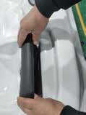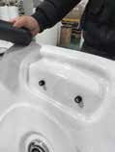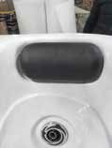

①

Grab the lower edge of the pillow with both hands firmly and pull up. As you do this, the pillow inserts will pop out of the holes.

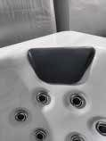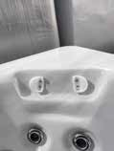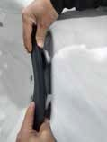

②

Reseat the pillows by aligning the pillow inserts with the holes and striking the pillow hard enough to insert the pegs back into the holes.

## **Air Valve**

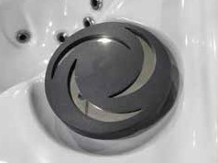

Air venturis are the 1” knobs located around the top of your spa. Each one will let you add a mixture of air with the jet pressure. This is accomplished by rotating the air venturi knob to the left (counterclockwise) to increase the amount of airflow through the jets. To decrease the amount of airflow through the jets, rotate the handle to the right (clockwise).

##### Screw-in jet removal

**Jet Removal and Replacement**

Grasp the outer rim of the jet and turn it count- er-clockwise. The jet will unscrew from the fitting until it is free.

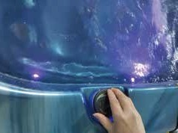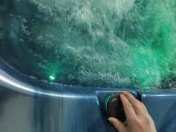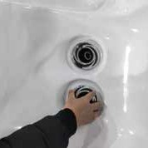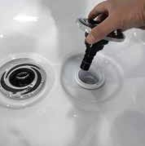

To replace the jet, place it in the fitting and turn

it clockwise until it is snug in place and it can be rotated freely about half a turn. Do not over- tighten the jet.

## **Waterfalls**



Some spa series include optional waterfalls. When the booster pump is on, rotate the dial on top (for the cascade waterfall) (see below).

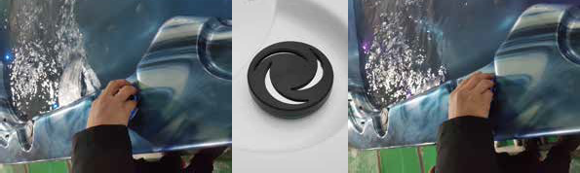

## **Draining Your Portable Spa**

Your spa should be drained every four to six months for cleaning and maintenance and refilled with fresh tap water. See page 19 for instructions on cleaning the shell, cover, and pillows. See page 7 for instructions on refilling your spa. Before you begin, turn off power to the spa at the breaker and remove all filters.

##### Locate your drain.

###### *For spas with drain inside the spa*

Remove the screws to the access panel and open it. Locate hose ending with the ¾ inch hose-bib fixture as shown below.

###### *For spas with cabinet-mounted drain*

Pull the knob out of the cabinet. The cabinet drain is screwed into the drain pull knob.

##### Remove the cap.

Make sure the valve is in the closed position, then unscrew and remove the cap. Unscrew the cap.

## **Cleaning and Replacing the Filter**

Filtration is one of the most important steps you can take to ensure clean, clear water. It is far less expensive to fix water clarity problems by filtering your spa than by using excessive amounts of chemicals, excessive filtration times, or by water replacement.

##### Set the spa in SERENITY MODE before you remove the filter. SERENITY MODE pauses all spa operations for service functions like cleaning or replacing the filter. See page 11 for instructions on using SERENITY MODE.

1. Remove the filter by unscrewing it and pulling it up and out.
2. Place the dirty filter into a bucket of water deep enough to cover the filter. Add 8 oz. of liquid filter cleaner to the bucket of water.

**Note:** It is a good idea to keep a spare filter to use in the spa while the dirty filter is being deep cleaned. This way, you can rotate the filters and both will last longer.

1. Soak the filter for a minimum of 24 hours.
2. Spray the filter with a water hose. Spray each pleat carefully.

###### *For spas with drain inside the spa*

**3. Connect valve to a garden hose.**

***For spas with cabinet-mounted drain***

5. Reinstall the filter. Do not overtighten.

Attach a garden hose to the hose-bib fixture. Place the other end of the garden hose where you would like the water to drain.

##### Drain the spa.

Turn the valve on the hose-bib fixture to open the drain. When the spa has drained completely, turn the valve on the hose-bib fixture, remove garden hose, and replace the cap.

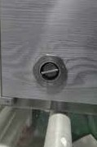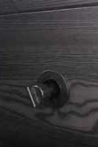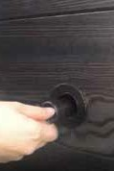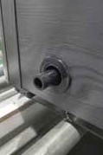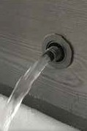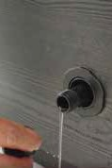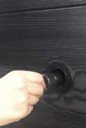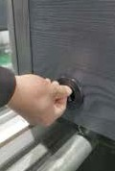

**Pull it all out**

1

2

3

4

**Once**

**Once**

5

6

7

8

**Push it all in**

## **Spa Cover and Locking System Installation**

Important! Keep the spa covered when not in use!

* + Covered spas will use less electricity in maintaining your set temperature.
  + Covering your spa will protect your spa’s finish from the sun’s ultraviolet rays.
  + You are required to keep the spa covered to maintain warranty coverage.
  + Covering your spa helps prevent children from drowning in the spa.

In addition, while the spa cover is rigid, it is not designed to support any weight. Therefore, as a safety precaution

and to preserve the life of your cover, you must not sit, stand, or lie on it, nor should you place objects of any kind on top of it.

Step 1 - Place cover on spa. Make sure it is correctly positioned.

Step 4 - Use a screwdriver to finish screwing in the 3 screws. (Repeat this process for the other 3 corners.)

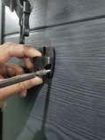

Step 5 - Keep the cover fastened down at all times when not in use. Locking hardware may be locked with a key (which is provided).

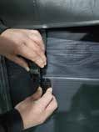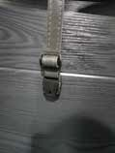

**LOCK**

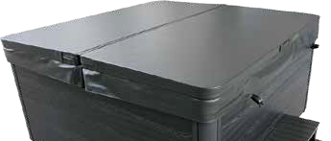

Step 2 - Position the tie-down hardware (attached to the straps of your cover) on the side of the spa so they are easily reached by the cover tie-down straps.

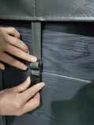

Step 6 - The provided key will allow you to lock down spa access.

WARNING AVOID DROWNING RISK

Step 3 - With the straps pulled taut (but not overly tight), lightly drill the location for screw placement. Gently drill 3 holesone for each screw slot in the lock. (If you do not have a low torque drill, use the lowest torque setting on the drill you have.) DO NOT drill all the way in but instead just make a guide for starters.

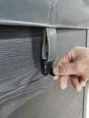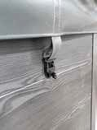

**KEY**

FALURE TO FOLLOW INSTRUCTIONS MAY RESULT IN INJURY OR DROWNING NON-SECURED OR IMPROPERLY SECURED COVERS ARE A HAZARD REMOVE COVER COMPLETELY BEFORE ENTRY OF BATHERS

ENTRAPMENT POSSIBLE

KEEP COVER ON SPA AND LOCKED WHEN NOT IN USE

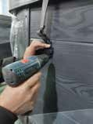 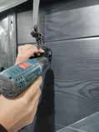

## **Vacation Care**

You can leave your spa unattended for up to two weeks if you follow these instructions.

###### *ALWAYS lock your cover using the cover locks if you plan to be away from home and the spa is filled with water.*

1. Select the Low Range temp choice used for vacation mode.
2. Following the water quality instructions starting on page 21, adjust the pH.
3. Shock the water (add either chlorine or bromine sanitizer).
4. When you return, check and adjust the pH and shock the water.

If you will not be using your spa for longer than 14 days and a spa maintenance service is not available, we strongly recommend you drain or winterize your spa.

## **Cleaning Your Spa**

**Using the Bluetooth Sound System**

The sound system is ready to pair when it is not already connected to another device. To pair your device , first make sure you are close enough to the system, and that it is turned on.

1. Open the Bluetooth settings on your device. The location of the settings will depend on the device you are using.
2. In these settings, turn Bluetooth on, if it is not already.
3. Choose "**JOYONWAY / Gecko in.stream / BBA spa Music**" from the list of available devices.
4. When prompted, enter **2288 / 5555 / 6000** as the password. Your device should now be paired with the system, and ready to use.

Once the pairing is done and connection has been established between the devices, the system will be ready to start playing the selected audio.If the device moves out of range and loses connection it should reconnect auto- matically as soon as it is close enough. This should happen without going through the menu again.

### Spa Cover and Pillows

|  |  |  |
| --- | --- | --- |
| **Brand** | **Bluetooth name** | **Password** |
| JOYONWAY | joyonway | 2288 |
| GECKO | instream2 | 5555 |
| BALBOA | BBA spa Music | 6000 |
|  |  |  |

Due to the constant punishment your spa cover and pillows receive, you should protect them by applying a vinyl and leather cleaner as part of your monthly maintenance plan. Use a product that is specifically designed to protect spa covers and pillows from chemical and ultraviolet light damage without leaving an oily residue behind that is normally associated with common automotive vinyl protectants.

**Warning: *Do not*** use automotive vinyl protectants on spa covers or pillows. These products are generally oil-based and will cause severe water clarity issues that are difficult to correct.

### Spa Shell

Each time you drain your spa, before you refill it you should clean your spa shell with an all-purpose cleaner and apply a coat of surface protectant.

Use a low detergent, non-abrasive cleaner specifically formulated to clean the spa without damaging its acrylic finish.

Use a non-oil based surface protectant that is specifically formulated to protect the spa’s finish from the chemi- cals and minerals associated with normal spa use.

This section is intended for new spa owners with no experience with water chemistry. Everyone’s experience with maintaining water quality is different, but there are some general concepts you need to know.

Water maintenance is not difficult, although it requires regular attention. The most important thing to understand about taking care of your spa water is that preventive action is much easier than correcting water quality issues.

### Covers

All spa covers are designed with a tapered height, angling downward from the center to the sides to drive off rain and prevent water from pooling. The covers listed below are filled with either 1.5 lb or 2.0 lb foam.

Before you begin, we recommend you become familiar with some water quality terms and their definitions.

Whether you’re filling your spa for the first time (see page 7) or refilling it after draining it for regular maintenance (see page 15), start and maintain your spa water by following the plan we describe in this section.

**Standard**

3.5” - 2.5” / 88mm - 64mm

1.5 Lb. foam

3.5”

Standard

**Deluxe**

5” - 4” / 125mm - 100mm

2.0 Lb. foam

5”

Deluxe

2.0 Lb. foam 4”

1.5 Lb. foam

2.5”

## **Basic Troubleshooting**



① **Chemical Balance**

You will need to test and adjust the chemical balance of your spa water. Although this is not difficult, it needs to be done regularly.

You need to test the level of calcium hardness, total alkalinity, and pH. Spa owners with a bromine generator also need to check

The troubleshooting guidance provided here is intended to cover the most common problems a spa owner may encouter. For more in-depth troubleshooting, go to [www.bellagioluxury.com.](http://www.bellagioluxury.com/)

**Symptom Possible Solutions**

##### Problems starting up

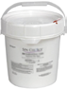

② **Sanitation and Shock**

Sanitizers kill bacteria and viruses and keep the water clean. A low sanitizer level will allow microbes to grow quickly in the spa water. We recommend using either chlorine or bromine as your sanitizer.

You also need to add shock to the water to stimulate the chemical sanitizer. How much you use and how often depend on frequency and intensity of use.

Pump won't prime See priming instructions on page 10.

Breaker keeps shutting off

##### **Power and system problems**



③ **Filtration**

Cleaning your filter regularly is the easiest and most effective single thing you can do to keep your water clear.

A clogged or dirty filter will cause the heater and pump to work harder than they need to, possibly causing them to fail.

The spa’s heating system will only function with the proper amount of water flow through the system.

Reset the GFCI breaker. If this continues, contact your dealer or a qualified spa technician.

System won’t start up or

breaker keeps shutting off

Power may be shut off. Turn on GFCI circuit breaker. If this continues,

contact your dealer or a qualified spa technician.

Control panel doesn’t respond

Turn on or reset the GFCI circuit breaker. If this does not solve the prob- lem, contact your dealer or a qualified spa technician.

If you hear the pump running but the control panel doesn’t respond, contact your dealer.

Maintaining your water quality helps the enjoyment of your spa and extends your spa’s life by preventing damage from neglect and chemical abuse.

④ **Regularity**

Clear water requires regular maintenance. Establish a routine based on a regular schedule for your spa water maintenance.

Spa does not turn off

Spa may be trying to heat up. Check if spa is in Ready or Rest mode.

In cold climates, if spa is not equipped with full foam or any kind of insula- tion, it will try to maintain the set temperature. Set the spa to low tempera- ture range and set the temperature to 80°F.

Spa may be in filter cycle. If it is, this is normal and no adjustment is neces- sary.

Message on the control panel

There may be a problem. Please scan the QR code on page 11 for instruc- tions.

**Symptom Possible Solutions**

**Symptom Possible Solutions**

##### **Heat problems**

**Water pressure problems**

Low water pressure

Jet valves may be partially or fully closed. Open the jet valves.

Filter cartridge may be dirty. Clean or replace the filter.

Pump may have airlock. Remove airlock by priming spa (page 10)

The suction fittings may be blocked. Remove any debris that may be blocking them.

The filter skimmer may be blocked. Remove the blockage.

Gate valves may be closed. Open gate valves. Note: Never operate your spa with the gate valves closed!

Spa may be running in filtration mode. Press JETS or JETS 1 button to turn on high speed pump.

No water pressure (no water stream from any jets)

Spa water does not get hot

Spa may be in low temperature range. Set the spa to high temperature

range.

The filter may be dirty or may need to be replaced. Clean or replace the filter.

The water level may be too low. Fill the spa with water level at 4 to 6 inches from the top.

The temperature is not turned up high enough. Raise temperature on topside control.

Cover the spa. The cover will keep heat in the spa and help keep heat from escaping. Make sure cover is on at all times when spa is not in use.

The heater element may be old, deteriorated, coated with scale, or defec- tive. Contact your dealer for more assistance.

The gate valves may be partially or completely closed. NEVER OPERATE YOUR SPA WITH THE GATE VALVES CLOSED!

Power may be switched off. Turn the power back on.

The pump may be defective. After you have tried all other troubleshooting, contact your dealer for assistance.

Jets surge on and off

Water level may be too low. Add water to normal level.

Spa overheats - temperature greater than 110°F / 43°C

Overheating can occur during summer months and may not necessarily indicate a malfunction. When it occurs, a message code may also appear on the control panel.

Temperature may be set too high. Turn the set temperature down to a lower temperature.

Filtration time may be too long. Turn the filtration cycles down during the warm months.

The spa may not be properly ventilated. Make sure the front of the spa is not blocked to allow air flow.

High speed pumps may have been running too long. Limit pump running time to no more than 15 to 30 minutes.

##### **Pump problems**

Pump runs constantly –

will not shut of

There may be a problem with circuit board. Contact your dealer

Noisy pump

The water level may be too low. Fill the spa with water level at 4 to 6 inches from the top.

Filter cartridge may be dirty. Clean or replace the filter.

Pump may have airlock. Remove airlock by priming spa (page 10)

The suction fittings may be blocked. Remove any debris that may be blocking the suction fittings.

Gate valves may be closed. Open gate valves. Note: Never operate your spa with the gate valves closed!

Air may be leaking into the suction line. Contact your dealer for assistance. Debris may be inside the pump. Contact your dealer for assistance.

Noise may be a sign of damage. Contact your dealer for service.

## **LIMITED WARRANTY**

**Symptom**

**Possible Solutions**

**Five Years on Spa Shell Structure:**

The spa shell structure is warranted against water loss due to defects in materials or workmanship for five (5) years from the original date of delivery.

### Five Years on Spa Shell Surface:

Pump turns off during

operation

Automatic timer may have completed its cycle. Press JETS or JETS 1 button

to start the cycle again.

Pump may have overheated due to the vents on the equipment door being blocked. Make sure the front of the spa is not blocked to allow air flow.

The pump motor may be defective. Contact your dealer for assistance.

The acrylic spa shell is warranted against cracking, blistering or delaminating due to defects in materials or work- manship for five (5) years from the original date of delivery. Surface checking is not included.

**Two Years on Spa Plumbing:**

Spa fittings and plumbing are warranted against leaks due to defects in materials or workmanship for 2 years from the original date of delivery.

Pump has a burning smell while running

A burning smell may be a sign of damage. Contact your dealer for service.

Pump does not run

Pump may have over heated. Let it cool for an hour and try operating the spa for a shorter time.

Power to the spa may be shut off. Turn on or reset the GFCI circuit breaker. If this does not solve the problem, contact your dealer or a qualified spa tech- nician.

### Two Years on Standard Spa Equipment - Electronic Spa Control Systems, Jet Pump(s),Circulation Pump and Heater:

The spa equipment systems are warranted against failure due to defects in materials or workmanship for two years from the date of delivery.

**One Year on Ozone Generator:**

The ozone generator is warranted against failure due to defects in materials or workmanship for one year from the original date of delivery.

### One Year on Blower:

The blower is warranted against failure due to defects in materials or workman ship for one year from the original date of delivery.

**One Year on Audio and Video System Components:**

The factory installed audio and video components (i.e. power supply, stereo topside, IR sensor, cables, wires, etc.) are warranted against failure due to defects in materials or workmanship for one (1) year from the original date of delivery.

### One Year on L.E.D.'s:

The factory installed L.E.D.'s are warranted against failure due to defects in materials or workmanship for one (1) year from the original date of delivery.

**One Year on Spa Cabinet:**

The spa cabinet is warranted to be free of defects in materials or

workmanship for one year from the original date of delivery. Normal wear or appearance is not included. This warranty does not include damage caused in delivery, variations in color, wear or appearance,as all wood reacts differently to environmental conditions.

### Ninety Days on Spa Pillows and Filter Box:

Pillows and filter box are subject to water chemistry variation and are warranted for ninety (90) days from the original date of delivery.

**Spa Covers:**

Spa covers are warranted to be free of defects in materials and workmanship for a period of two (2) years on vinyl and one (1) year on foam core.

### Spa Accessories:

The spa accessories are warranted by the accessory manufacturer and are specifically excluded. Please see the respective product manufacturer's warranty for details.

### In-field labor shall be covered by dealers.

**Limited Warranty should be read in conjunction with Warranty Performance.**