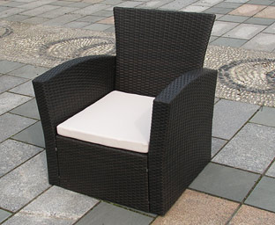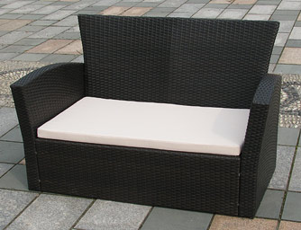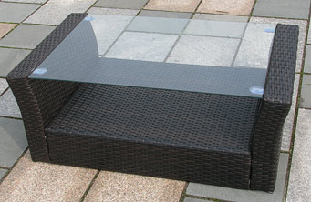

Ca. 71 cm

Ca. 85 cm

Ca. 36 cm

Ca. 50 cm

Ca. 69 cm

Ca. 72 cm

Ca. 53 cm

Ca. 53 cm

Ca. 80 cm

Ca. 51 cm

Ca. 29 cm

Ca. 59 cm

Ca. 80 cm

Ca. 69 cm

Ca. 51 cm

Ca. 122 cm

Ca. 106 cm

Ca. 53 cm