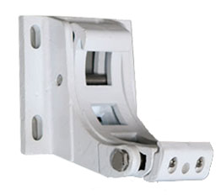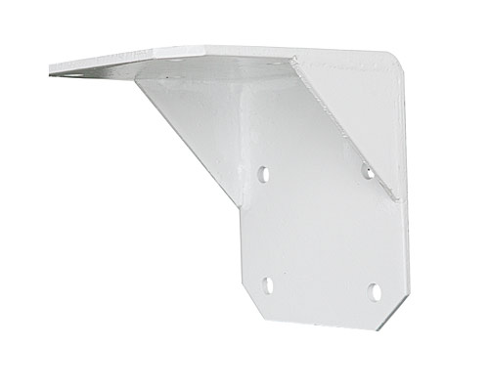

22 mm

105 mm

22 mm

202 mm

184 mm

65 mm

150 mm

11 mm

137 mm

65mm

18mm