INSTRUCTION MANUAL

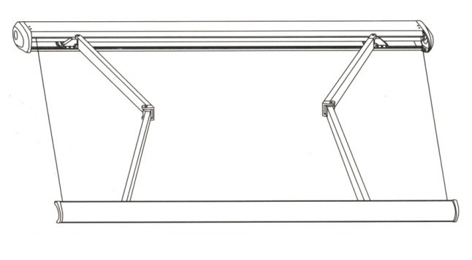

·FULL-CASSETTE AWNING

Important safety instructions
WARNING NOTE:
FOR PERSONAL SAFETY,IT IS IMPORTANT TO FOLLOW THESE
INSTRUCTIONS,PLEASE KEEP THESE INSTRUCTIONS IN SAFE PLACE
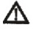
This warning triangle calls attention to Awning is intended primarily as protection
Hazards that can lead to death or to severe against the sun.If a wind starts up or it
Injuries or which are important for the begins to rain heavily(formation of water
Functioning of the awning. pockets)or snow begins to fall,it should
be retracted immediately.Operating them
in winter conditions can result in demage
This sign indentifies important notes Required Tools
·Drill
·Masonry drill bit,14mm
Read these instructions carefully before you ·Level
Begin with the assembly or operate the ·Wrench
Awning. ·Stepladder

Note:
Before assembly please check whether the Sheeting was used to protect the paint
Delivered assembly brackets agree in type This must be removed afterwards.
And amount with the order and whether the
Mounting base specification provided in the
Order coincide with the actual conditions. Warning:
The awning is heavy.A minimum of two
When extended,various forces,including Persons is required to attach the awning
wind and rain,will affect an awning,These to the wall brackets.
sometimes substantial forces must be
absorbed by the awning and transferred to DO NOT TRY TO attach the awning alone.
the assembled structure via its mounting If the awning falls,it may cause serious
brackets.under extreme loads,excessive injuries and get damaged.
tractive force can be exerted on the anchor
bolts.
DO NOT ALLOW CHILDREN TO PLAY IN
Therefore,before starting assembly,check THE WORK AREA DURING ASSEMBLY
the load bearing capacity of the mounting AND ADJUSTMENTS.
base and if necessary take corresponding
meansures to ensure stable installation of the Please make sure that your hands are
brackets.If the mounting base is unstable, clean at the time of the assembly,
you may wish to consult a specialist in your otherwise you may soil the awning fabric
vicinity and frame.
Parts List
PARTS LIST | PICTURE | OPTIONS
Awning Unit | 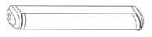 | 
Bracket or ceiling bracket | 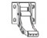
Bolt | 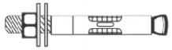
Hand-crank | 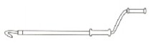
Motor Adjustor | 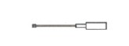
Remote Control System | 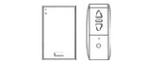
Catalogue | 
Video | 
Note:

- Awning unit is including:economic awning or no cassette awning or half cassette awning
- Bracket:<3.6m awning is with two brackets,3.6~5.1m is with three brackets,5.1~6.0m is
- Bolt:on bracket is matched two bolts
- Hand-crank:one manual awning is matched one hand-crank
- Motor adjustor:one motor is matched one adjustor
- Remote control system:M01 motor is including one emitter,M02 is including one emitter
And receiver,M03 is including one emitter,receiver and hand crank,M04 is including
One emitter and hand-crank

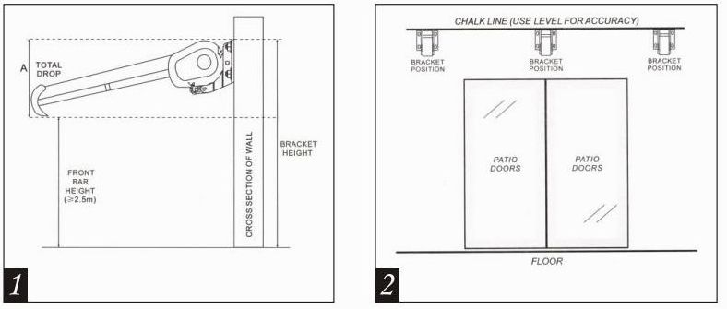
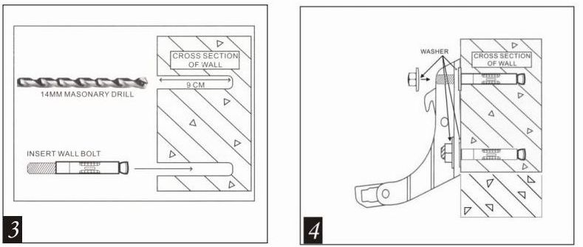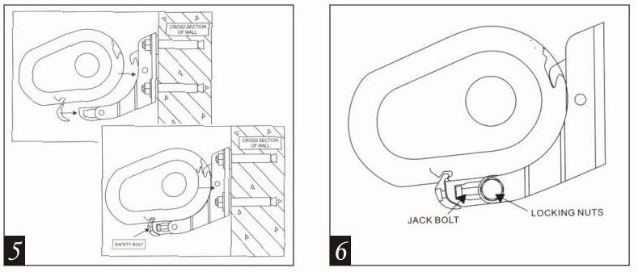
Assembly
Step 1:
Careflly remove the awning from the box and remove the Styrofoam protectors from the awning.
remove the plastic bags and plastic guards from the awning and carefully place the awning aside
to avoid having it damaged by scratches or otherwise damaged or soiled during assembly.

Think about how you will be securing the awning to the wall ahead of time.In the event you would
like to mount it above a patio door.You should leave a space of at least 20cm above the door frame
If there is enough space available above the door frame.

The approximate total drop area of the awning varies depending on the type:
Bracket Height | 3~5m | 4.5~6m
A(Total Drop) | 30cm | 50cm
Ensure that you also take this drop height into account in your decision on where to install the
awning.The drop angle can still be changed after assembly.The ideal drop angle,however,
hs already been sent in the factory and may only be changed minimally.
picture :it shows the drop of the awning when it is fully extended.(Total drop,height of front bar
≥2.5m,cross section of the wall,bracket height)

Step 2:
The positions of wall brackets ware marked on the awning in the factory.
measure the width of the awning with a ruler and note the positions of wall brackets.
picture :Draw a horizontal line at the height of the required places as illustrated in the image and
use a long ruler,a level and chalk for this purpose.
mark the corresponding places on the wall by running apencil through the holes at the bottom of
the brackets.

Step3:
Use a 14mm masonry drill bit to drill the holes for the brackets at the appropriate marks on the wall.
Picture :The holes should be 9cm deep in the wall and must be drilled through solid brick or
concrete.Do not drill through mortar because this does not offer the support that is required for the
awning.

Installation on timber houses and sheds:
The awning can also be installed on timber houses if their walls can carry the weight of the awning.
in this event,ensure the brackets are firmly secured to the outside of solid woonden beams.
the anchor bolts from the delivered package are not suitable for mounting the awning to wooden
beams.Instead buy carriage bolts of adequate length and of an appropriate diameter and secure
the awning with them.

Step 4:
Attachment brackets for wall
Picture :After inserting the wall bolt,add the washers and then the wall brackets.Now place the
Washers on the bolt heads and firmly tighten the 17mm nuts.

Note:

1.t may be necessary to drive the anchor bolts in with a wooden mallet because they do not go in easily.
Do not use a metal hammer for this purpose because this could damage the threads on the top of the
Bolts.
2.If the bolts need to be driven into the wall with a hammer,we remomend initially placing the nut on the
Screw loosely(only placing it loosely on the bolt) because this avoids damaging to the bolt threads.
3.Firmly tighten the bolts with a 17mm hex key:it is best to use a hex key with a closed end rathae than an
Open end because this will avoid damaging to the nut of it should slip.
4.As soon as they are fully inserted,the brackets must sit firmly in the wall.If they are still moving in any
Form.you must further tighten it.
5.Do not try to secure the wall brackets to loose wall stones or any surfaces that are not absolutely firm.
6.Ensure that the wall brackets are screwed firmly to the wall,so that they can in no case tear out when
The awning is installed.

Step5:
Now your awning can be secured to the wall brackets.
Picture :At least two ladders or chairs are required to install the awning in order to obtain the required
Height.Ensure that the ladders or chairs are firmly resting on the ground so that you can not fall.only
Use ladders that are suitable for such assembly work.
Note:
In case tha pole can not be inserted into the wall brackets,you should sightly loosen the wall brackets
Screws and then try it once again.
This time,move the awning slightly forward and backward until the pole slips into the brackets.
Then immediately insert the safety bolts on the front side of the wall brackets and tighten the nuts with a
19mm hex key.Ensure that the safety bolts for the wall brackets have been adequately secured.

Step 6:
Remove the protection belts from the awning if you have not done so already.Open the awning now,you
Will discove the awning is not level,you can adjust the angle of arms to level it.
Picture :Loosen the 4*17mm LOCKING NUTS and then turning the 2*13mm JACK BOLT by a spanner
To the desired angle.

Note:
The forward pole must always be level.To ensure that both sides are completely level,a built-in level is
Located on the forward side:the air bubble must be exactly in the middle of the level.
Place the plastic screw caps on the screws to protect them against weather based corrosion.
Now you can use your awning.After using it.Always remove the hand-crank and keep it in a safe and dry place.
PLEASE DO NOT LET CHILDREN PLAY WITH THE AWNING.
If you have any questions about installation or if you require spare parts,please contact your dealer.
BE SURE TO NOTE.
The awning’s gear bos have no stop to limit revolutions of the roller.To avod damaging to the fabric,
Therefore,the awning fabric must always be properly roller up.The fabric must be stretched tightly.

ANY QUESTION OF MOTORIZED OPERATION,PLEASE REFER TO THE MOTOR INSTRUCTION.
Repair Manual for Usual Malfunction

No. | PHENOMENON OF MALFUNCTION | REASON | REPAIR METHOD
1 | The awning does not work when operated by remote control | ①No power supply | ①Check the plug to see whether its properly connected
1 | The awning does not work when operated by remote control | ②The redidual current  automatc circuit breaker is at “off” position | ②Call on the professionals to inspect
1 | The awning does not work when operated by remote control | ③The voltage is too low | ③Call on the professionals to inspect the voltage whether it accords with the requests
2 | When operated by remote control,the awning does not work although the receiverd signal from remote receiver can be heard | ①Remote receiver and motor are switched or wire from motor disconnected with pin | ①Check two placed:fasten pins and screws
2 |  | ②The motor switched off due to overheat protection | ②The more will automatically resume operation after approx.  20minutes interval
3 | Fabric s lax though the awning is extended entiredly | Path length is incorrectly adjusted | Readjust path length according to the direction of the motor.
4 | The cassette can not be close completely | Connecting position between front bar and front beam moved | Adjust position of the front beam till the cassette entirely shuttered
5 | Unwanted noise when operating | Screw loosened | Check all screws come ine view and fasten the loosened
6 | When operated by remote control,the indicative lamp does not work and no signal from receiver. | ①Cell exhausted | ①Changed a new cell
6 |  | ②Cell disconnected | ②Reset the cell

