Acrylic Bathtub Make-Up
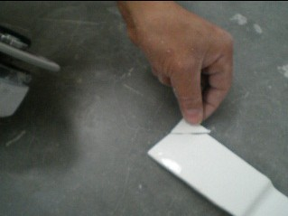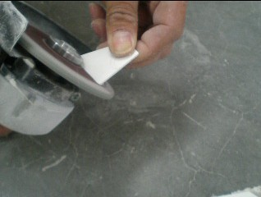

1、Finding a piece of acrylic sheet matching the breakage, also can use polisher to make a proper sheet
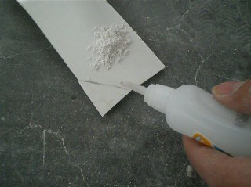
2、Clean the lip of breakage and use “502” glue it
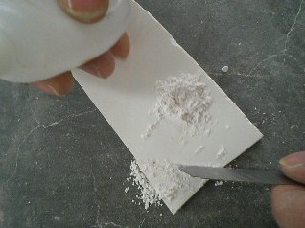
3、Cover the joint and fill it with whitening
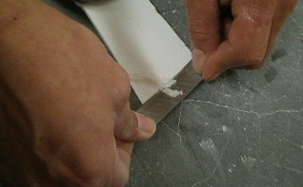
4、After the glue dry, shave the excess whitening with knife.
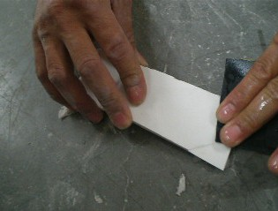
5、Use mesh to polish the joint smoothly
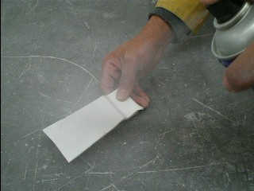
6、Dry the surface of joint, Paint the joint surface with white hand-painting evenly(can paint several times depends on the looking of joint, each time before painting, make sure the painting on the joint is dry.)

